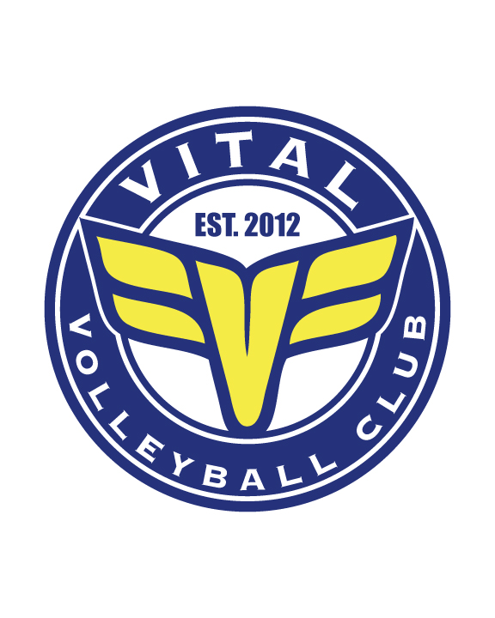
Vital Volleyball Club : COVID-19 Waiver

Participant Name: ________________________________________________ (Printed)

Vital Volleyball Club Communicable Disease Waiver and Release
READ BEFORE SIGNING

In consideration of being allowed to participate in any way in Vital Volleyball training, related events and activities, the undersigned acknowledges, appreciates, and agrees that:
1. The risks of injury and illness (ex: communicable diseases such as MRSA, influenza, and COVID-19) from the activities involved in this program are significant, including the potential for permanent paralysis and death, and while particular rules, equipment, and personal discipline may reduce these risks, the risks of serious injury and illness do exist; and,
2. I KNOWINGLY AND FREELY ASSUME ALL SUCH RISKS, both known and unknown, EVEN IF ARISING FROM THE NEGLIGENCE OF THE RELEASEES or others, and assume full responsibility for my participation; and,
3. I willingly agree to comply with the stated and customary terms and conditions for participation. If, however, I observe any unusual significant hazard during my presence or participation, I will remove myself from participation and bring such to the attention of the nearest official immediately; and,
4. I, for myself and on behalf of my heirs, assigns, personal representatives and next of kin, HEREBY RELEASE AND HOLD HARMLESS Vital Volleyball, their officers, officials, agents, and/or employees, other participants, sponsoring agencies, sponsors, advertisers, and if applicable, owners and lessors of premises used to conduct the event (“RELEASEES”), WITH RESPECT TO ANY AND ALL INJURY, ILLNESS, DISABILITY, DEATH, or loss or damage to person or property, WHETHER ARISING FROM THE NEGLIGENCE OF THE RELEASEES OR OTHERWISE, to the fullest extent permitted by law.
I HAVE READ THIS RELEASE OF LIABILITY AND ASSUMPTION OF RISK AGREEMENT, FULLY UNDERSTAND ITS TERMS, UNDERSTAND THAT I HAVE GIVEN UP SUBSTANTIAL RIGHTS BY SIGNING IT, AND SIGN IT FREELY AND VOLUNTARILY WITHOUT ANY INDUCEMENT.

Participant Signature: _______________________________

DATE SIGNED: ______________________
FOR PARTICIPANTS OF MINORITY AGE (UNDER AGE 18)

This is to certify that I, as parent/guardian with legal responsibility for this participant, have read and explained the provisions in this waiver/release to my child/ward including the risks of the activity and his/her responsibilities for adhering to the rules and regulations. Furthermore, my child/ward understands and accepts these risks and responsibilities. I for myself, my spouse, and child/ward do consent and agree to his/her release provided above for all the Releasees and myself, my spouse, and child/ward do release and agree to indemnify and hold harmless the Releasees from any and all liabilities incident to my minor child’s/ward’s involvement or participation in these activities as provided above, EVEN IF ARISING FROM THEIR NEGLIGENCE, to the fullest extent permitted by law.

Parent / Guardian Name: __________________________________________________

Parent / Guardian Signature: ________________________________________________

DATE SIGNED: _____________________

